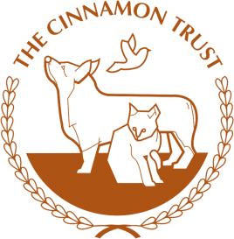
The Big Walk 2024

Sponsorship Form

Name |  | CT ID:
Tel: |  | Email:
Address: |  | Town/City
Line 2: |  | Post Code
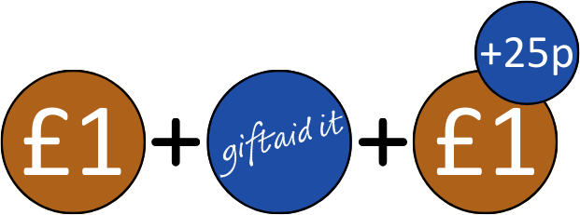
If I have ticked the box headed 'Gift Aid', I confirm that I am a UK Income or Capital Gains taxpayer. I have read this statement and want The Cinnamon Trust to reclaim tax on the donation detailed below, given on the date shown. I understand that if I pay less Income Tax / or Capital Gains tax in the current tax year than the amount of Gift Aid claimed on all of my donations it is my responsibility to pay any difference. I understand the charity will reclaim 25p of tax on every £1 that I have given. I understand that I cannot Gift Aid any donations made by, or on behalf of a group, company or someone else.

Title | Full Name | Address Line 1 | Postcode | Date | Amount | Gift aid
Mr | John Jones | 1 Station Rd | TR27  4HE | 09.04.24 | £25 | ✓

Title | Full Name | Address Line 1 | Postcode | Date | Amount | Gift aid

Total Raised £
Simply collect your donations email your sponsorship form(s) to bigwalk@cinnamon.org.uk and make a bank transfer to:
Payee Name: The Cinnamon Trust
Account No: 83199231
Sort Code: 20-87-94
Thank You!
Or send us a cheque made payable to ‘The Cinnamon Trust’
(please do not send cash) along with your completed sponsorship form(s) to:

The Cinnamon Trust, 10 Market Square, Hayle, Cornwall, TR27 4HE.
For office use only
Date Monies Received:
Total Gift Aid Donation:
Total Donation Amount:
The Cinnamon Trust - Registered Charity Number 1134680 www.cinnamon.org.uk Email: bigwalk@cinnamon.org.uk Tel: 01736 757 900

