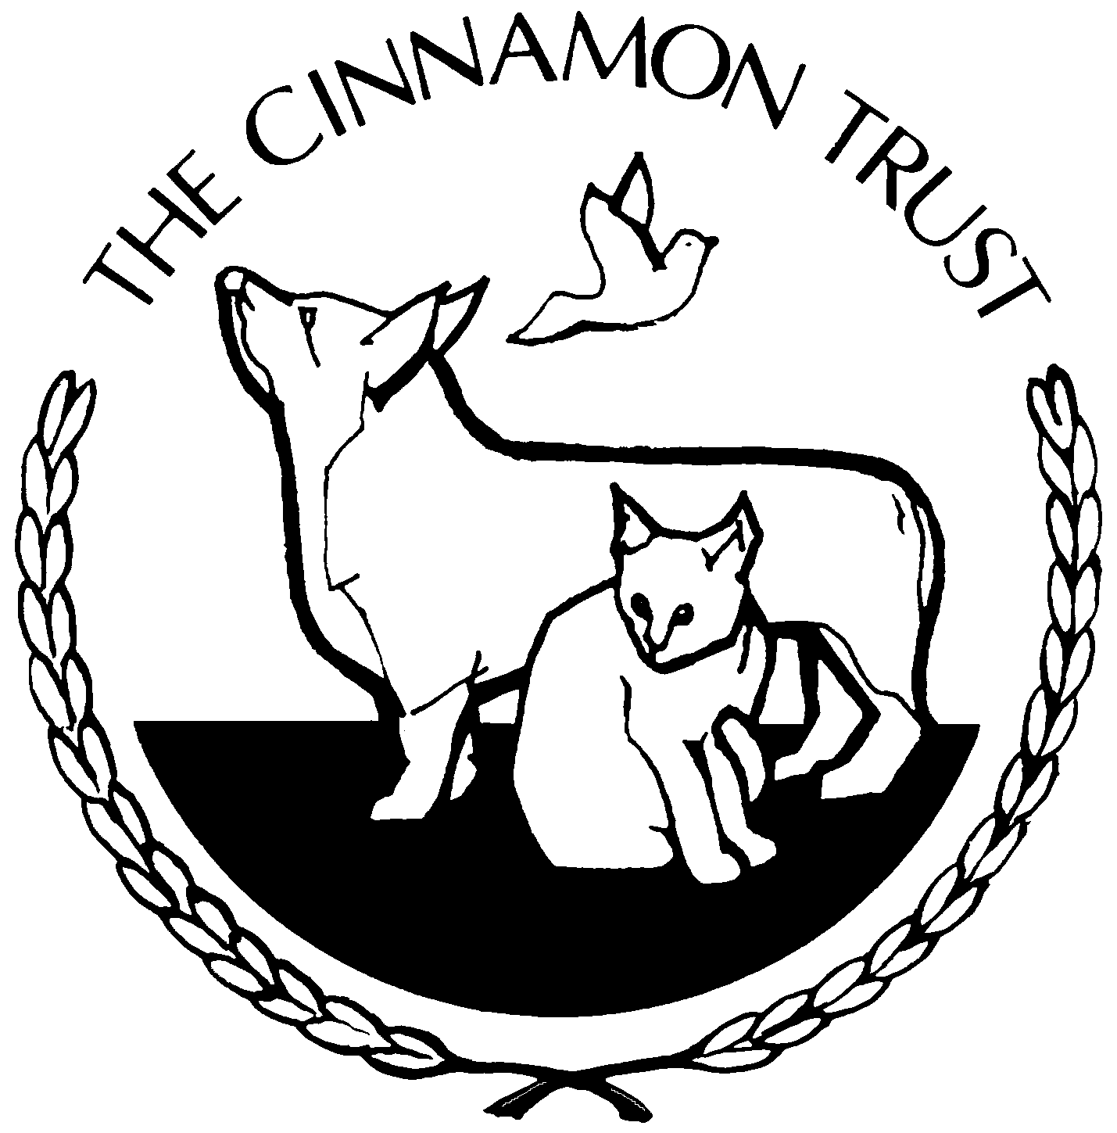
The Cinnamon Trust

JOB DESCRIPTION

Job Title : Fundraising & Events Officer

Salary : £26,000 per annum

Hours : 35 hours per week (Mon – Fri, 9am to 5pm) plus days
attending events (this may include overnight stays)

Section : Operations

Responsible to : Head of Operations/Fundraising

MAIN PURPOSE OF JOB:

To provide excellent support to the Head of Operations having full regard to the charity’s objectives and priorities at all times, meeting or exceeding the Charities legal, ethical and moral standards. Lead by example by showing the ability to communicate interpersonal skills, problem solve, decision making and time management. To ensure that you work effectively in terms of daily operations. To build a rapport with our clients in a warm and friendly manner and have empathy with our clients’ needs. To quickly identify any problems and ensure each conversation is handled in a compassionate manner.

Developing and leading on the delivery of existing fundraising events as well as developing and delivering future events (which will include overnight stays) Build high value relationships with members and donors, for a wide range of audiences and media, supporting communications and marketing activities, working closely with colleagues across the organisation.

A good telephone manner is essential, together with excellent literacy, verbal analytical and IT skills, coupled with the ability to work to tight deadlines, often under pressure. To be able to show initiative and a ‘can do’ attitude at all times

** The Fundraising and Events team are very busy and flexibility is required at busy times throughout the year.

MAIN DUTIES AND RESPONSIBILITIES:

Fundraising

- Work collaboratively with multiple internal stakeholders to capture and understand requirements, identify new opportunities or build on existing activity to help achieve income targets.

- To data input and maintain events in line with current practices.

- To help find volunteers to attend events.

- To send out and organise fundraising merchandise and materials for Cinnamon Trust and volunteer events.

- Handle general telephone and personal enquiries regarding fundraising and events.

- Undertake any other reasonable and related tasks, as required by the Marketing and Fundraising team .

- Have a good working knowledge of charity legislation and work to the Institute of Fundraising Codes of Practice and Fundraising Standards.

- To liaise with, and assist other members of the fundraising team.

Events

- To be available to attend major events for The Cinnamon Trust, making sure that all holidays are worked round our events diary.

- To drive The Cinnamon Trust van and trailer to events.

- To promote The Trust at events and always present a positive and professional image.

- To make sure the appearance of the stand is always presentable.

- To manage volunteers at an event and give a briefing at the beginning of the day regarding objectives.

- To seek any permissions required for an event and complete risk assessments required.

- To make sure that furniture and other equipment is available at each event.

- To make sure all materials for an event are event appropriate (eg: could be a volunteer driven event or PP) and well stocked.

- To account for stock and merchandise for each event and fill out request forms that will be logged against each event.

- To make sure that any cash taken at an event is kept safe.

- To liaise with the PR and Marketing department regarding events and to supply photos and copy for their use. To work with the PR and Marketing team regarding fundraising campaigns and promotions.

Together with such additional general duties as the Employer shall reasonably require, having regard to the needs of the Employer’s business as a Charitable Trust.

